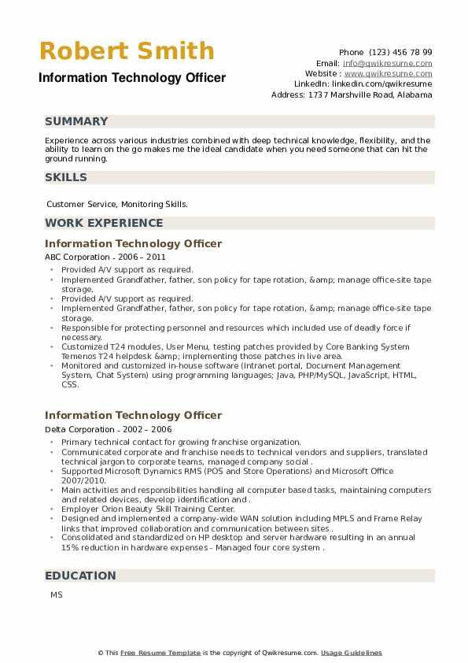
Robert Smith
Information Technology Officer
Phone (123) 456 78 99
Email: info@qwikresume.com Website: www.qwikresume.com Linkedin: linkedin.com/qwikresume Address: 1737 Marshville Road, Alabama
SUMMARY
Experience across various industries combined with deep technical knowledge, flexibility, and the ability to learn on the go makes me the ideal candidate when you need some one that can hit the ground running.
SKILLS
Customer Service, Monitoring Skills.
WORK EXPERIENCE
Information Technology Officer
ABC Corporation - 2006-2011
• Provided A/V support as required.
• Implemented Grandfather, father, son policy for tape rotation, &amp; manage office-site tape storage.
•Provided A/V support as required.
Implemented Grandfather, father, son policy for tape rotation, &amp; manage office-site tape storage.
Responsible for protecting personnel and resources which included use of deadly force if necessary.
Customized T24 modules, User Menu, testing patches provided by Core Banking System Temenos T24 helpdesk &amp; implementing those patches in live area.
⚫ Monitored and customized in-house software (Intranet portal, Document Management System, Chat System) using programming languages; Java, PHP/MySQL, JavaScript, HTML, CSS.
Information Technology Officer
Delta Corporation-2002-2006
⚫ Primary technical contact for growing franchise organization.
• Communicated corporate and franchise needs to technical vendors and suppliers, translated
"
technical jargon to corporate teams, managed company social.
Supported Microsoft Dynamics RMS (POS and Store Operations) and Microsoft Office 2007/2010.
• Main activities and responsibilities handling all computer based tasks, maintaining computers and related devices, develop identification and.
• Employer Orion Beauty Skill Training Center.
Designed and implemented a company-wide WAN solution including MPLS and Frame Relay links that improved collaboration and communication between sites..
⚫ Consolidated and standardized on HP desktop and server hardware resulting in an annual 15% reduction in hardware expenses - Managed four core system.
EDUCATION
MS
This Free Resume Template is the copyright of Qwikresume.com. Usage Guidelines

